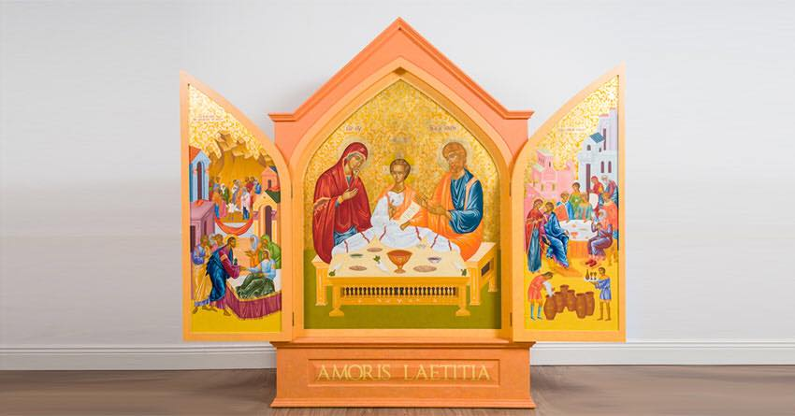

WORLD MEETING OF FAMILIES ICON
The Icon for World Meeting of Families 2018 will be brought to St. Mark’s Church, Springfield on Wednesday, 18th July, at
12 noon.

There will be a short Prayer Service upon its arrival at 12 noon and again at 3pm and 7pm. The church will be open until final prayers at 7pm.

All are invited to come to one or all of the Prayer Services, or just to spend a little quiet time in the church at any stage during the day.

The Icon of the Holy Family will be accompanied by
petition boxes where families can write their intentions and prayer. Contemplative communities around Ireland will pray for the intentions collected over the coming year. Petitions will also be brought to World Meeting of Families 2018.

