Praying the Scripture - a few simple steps at home

Sunday 16th Jan 2022
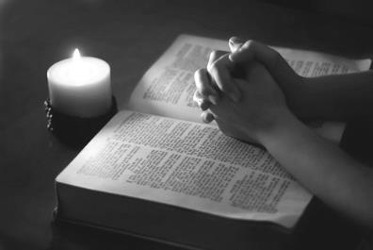
- Start with stillness and quietening down; then gently read the passage, noticing any feelings and connections to your own experience.

- Read the passage again and spend understand. The notes in your Bible may be of help at this point.

- Read the passage a third time - wondering how you yourself might pray the text over the next few days.

- Over the next week, set aside times to come back more than once to the passage. You could read it all or part of it again, slowly. Perhaps there is a special word for you in this passage of Scripture? Keep this word or phrase in your thoughts and gently repeat it, bringing it to mind and allowing God to speak to you in your heart.

- Finally, come back to the text to conclude: What is God in this scripture asking of you this week? What is the one challenge, one little change you are asked to make or the thing you have been asked to do? Then say a prayer of thanksgiving for the good news in the passage. End in quiet prayer.
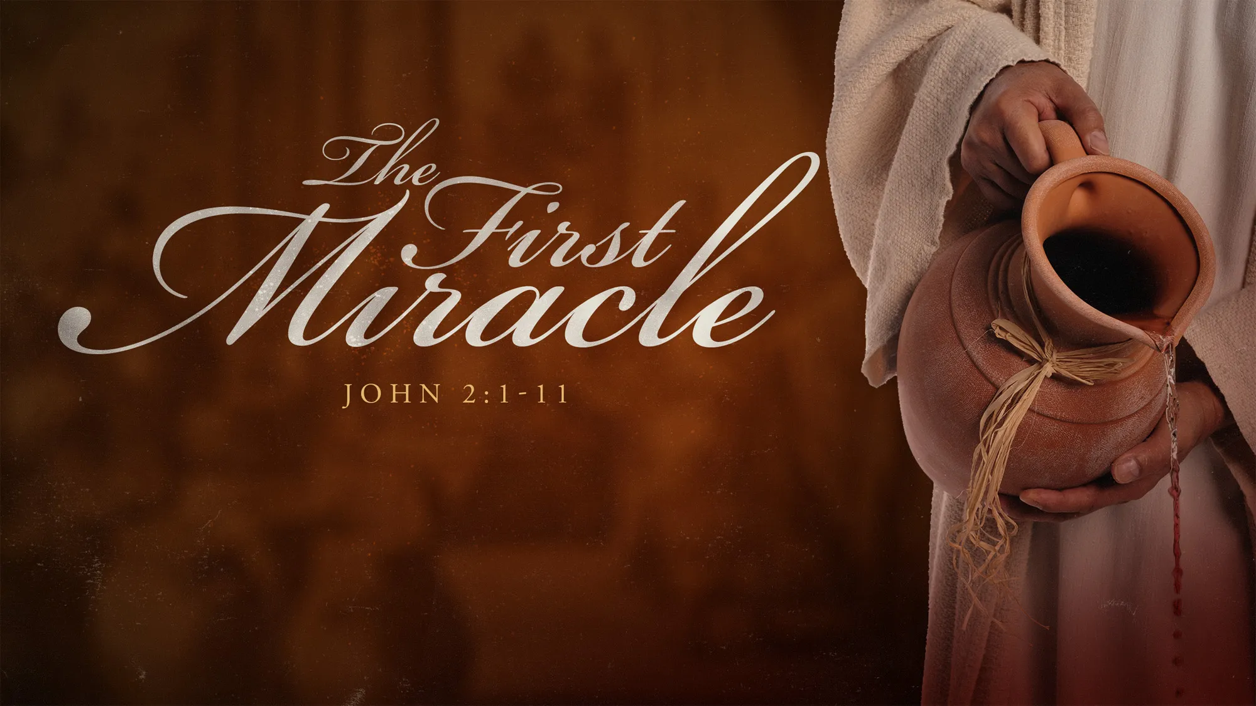
THIS SUNDAY’S GOSPEL – Jn 2:1-11

On the third day there was a wedding in Cana of Galilee, and the mother of Jesus was there. Jesus and his disciples had also been invited to the wedding. When the wine gave out, the mother of Jesus said to him, ‘They have no wine.’ And Jesus said to her, ‘Woman, what concern is that to you and to me? My hour has not yet come.’ His mother said to the servants, ‘Do whatever he tells you.’ Now standing there were six stone water-jars for the Jewish rites of purification, each holding twenty or thirty gallons. Jesus said to them, ‘Fill the jars with water.’ And they filled them up to the brim. He said to them, ‘Now draw some out, and take it to the chief steward.’ So they took it. When the steward tasted the water that had become wine, and did not know where it came from (though the servants who had drawn the water knew), the steward called the bridegroom and said to him, ‘Everyone serves the good wine first, and then the inferior wine after the guests have become drunk. But you have kept the good wine until now.’ Jesus did this, the first of his signs, in Cana of Galilee, and revealed his glory; and his disciples believed in him.

A Short Thought
“Do whatever he tells you.” - I love Mary’s words here. She has no idea what Jesus is going to do, but she knows it will be OK. And this is not some great, earth-shatteringly important world event. It’s a friend’s wedding, and the caterers have messed up. This is ordinary, real life. And God is right there, being involved. This is prayer about real things.
Sometimes I feel a bit of a fraud when I pray. A friend is ill. Do I pray for miraculous healing, or for a favourable outcome to his latest blood test, or for fortitude to cope with the symptoms? Exam time. Do I pray for straight A’s, or for good questions, or for a positive attitude for whatever results I get? I don’t want to second-guess God, or tell him what I think he should do, but I feel like a fraud for praying ‘do whatever you think best, God.’ Isn’t that a bit of a cop-out?
I suppose it is. It’s an easy prayer and I can look back and say ‘Yep, my prayer was answered’, no matter what the outcome. It feels a bit wish-washy. There is none of the assurance that comes with praying for a specific outcome and then seeing it. So, which should I do? Should I use my limited wisdom and imperfect grasp on the whole situation to pray that a friend will pass her driving test, or bring it before God and leave the rest up to him? What if God wants her to fail?
Should I be bold and specific in prayer, or is it that telling the Almighty what to do, thinking I know better than him? Should I be more general, humble in the face of God’s wisdom, or is that being feeble and faithless?
I’d say both. Daring prayer is good. But we do not have to plan God’s solutions for him. We can trust that our Lord knows what he’s doing better than we do. “As the heavens are higher than the earth, so are my ways higher than your ways and my thoughts than your thoughts.” (Isa 55:9) However, we also need to make sure we are not just evading specifics with a limp-wristed, wet-lettuce Christianity that can never see answered prayer because it is so vague that anything is an answer and not.
God loves to hear us pray and wants us to bring our requests to him, however small. “Do not be anxious about anything, but in every situation, by prayer and petition, with thanksgiving, present your requests to God.” (Phil 4:6) We also need to bring the big issues before him, not because he does not know, but because in doing that we can join our hearts and minds with his. Praying is much more about changing us than changing things. Mary brought to Jesus a small problem, and I love how he provided far more than required. This is our lavish, loving Lord. Mary could have asked for a specific result – that the guests would leave early, that a fresh supply of wine would be discovered behind some cloaks, that everyone would suddenly become teetotal. Instead, she left the choice of solution with Jesus, safe in the knowledge that he would sort it.
So we don’t need to beat ourselves up if we cannot in full faith pray for a miraculous healing. If God has put that on your heart then go for it, and know that our mighty Lord is more than able. But if God has not put that on your heart, then do not feel that you are a disappointing failure for praying differently. Maybe that is not what God wants you to be asking. We cannot pretend before God. He would far rather have honest mustard-seed faith than cardboard cut-out mountain faith.

SOME POINTERS FOR PRAYER

- Mary is here at the feast. It was through her sensitive awareness that Jesus came to know about the bridegroom’s predicament. It is through the Christian community that Jesus comes to us. It is through the Church, through our brothers and sisters in the community, that we learn about the life that God in Jesus wants us to enjoy and share with him and others we meet. Where do you see God in your community?
- The marriage imagery puts all the emphasis on love, an emphasis found richly in this Gospel, in St Paul and, of course, in Jesus’ own teaching. Go back to significant experiences of being loved and how these have opened your own heart to receive and to give in love.
- A banquet – and the free flow of wine – was always, for the people of God, a figure of the total fulfilment and happiness which would mark the Lord’s final future coming. His overflowing generosity is always available to us. Where have you experienced this generosity in your own life?
- The wine symbolises true joy in believing—a bit of a challenge these days, but central nevertheless and even life-giving. Where do you find your springs of joy?
- Do whatever he tells you” is a strong invitation to conformity to Christ on the path of discipleship. That have been the important points on that path? And where am I now?
Prayer

God of wonders, at Cana in Galilee, you revealed your glory in Jesus Christ and summoned all humanity to life in him. Show to your people gathered on this day your transforming power and give us a foretaste of the wine you keep for the age to come. We ask this, as always, through Jesus Christ your son, Amen

Prayer in these uncertain times
We pray for all those in our country and throughout the world suffering from the Corona Virus. May its victims and their families be strengthened by the support of our community of faith and restored soon to full health. We also pray for our leaders and medical personnel who deal with the virus. May we keep calm and may we join together in solidarity with care and compassion to tackle this emergency. This we ask in confidence through Christ Our Lord. Amen

